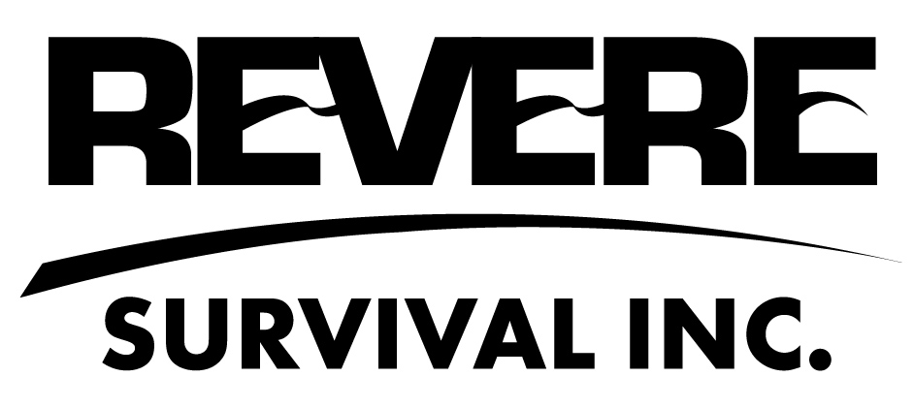

OWNER’S MANUAL

AERO ELITE SERIES
LIFERAFTS

REVERE SURVIVAL INC.
5323 Highway Ave.
Jacksonville, Florida 32254 USA
Tel. No. (904) 503-9733
Fax. No.(904) 503-9719
www.reveresurvival.com

Table of Contents

Section 1.0 Warnings and Cautions

Section 2.0 Normal, Non-Emergency Handling

Section 3.0 Installation and Storage

Section 4.0 About Your Raft
4.1 Construction
4.2 Inflation System
4.3 Ice Build Up
4.4 Ballast Bag System
4.5 Pressure Relief Valve
4.6 Locator Light
4.7 Inflatable Insulated Floor
4.8 Canopy Door and Window
4.9 Rainwater Collector
4.10 Sea Anchor

Section 5.0 Periodic Service and Maintenance

Section 6.0 Operating Procedures
6.1 Inflation
6.2 Righting
6.3 Boarding
6.4 Cast-Off

Section 7.0 Immediate Action Checklist

Section 8.0 Survival Equipment Pack
8.1 Topping-Off with Handpump
8.2 Deflation
8.3 Bailing Bucket and Sponges
8.4 Raft Repair Kit
8.5 Paddles
8.6 Signaling Devices
8.6.1 Signal Mirror
8.6.2 Whistle
8.6.3 Flashlight
8.6.4 Pyrotechnic Signal Flares

1.0 WARNINGS AND CAUTIONS

- CYLINDER UNDER PRESSURE. DO NOT HEAT CYLINDER.

- DISPOSE OF CYLINDER ONLY WHEN EMPTY. DISPOSE OF IN ACCORDANCE WITH LOCAL, STATE, AND FEDERAL REGULATIONS.

- The raft contains a compressed gas cylinder filled with carbon dioxide gas under high pressure. Handle accordingly. Ship this raft in accordance with local, state, and federal transportation regulations for shipping a self-inflating, life-saving appliance (UN 2990).

- Do not test inflate this raft for practice or amusement. Doing so may damage parts of the raft that would not need repair or replacement had a normal periodic service inspection been performed at a qualified service center.

- The raft's fabric valise is designed to tear apart under certain rapid inflation situations. Test inflating the liferaft may require costly repair or replacement of the case.

- Do not attempt to repack the raft yourself. The raft is designed to be folded a specific way to avoid tangling, tearing, capsizing, and fabric bursting. Only a qualified service center should repack this raft.

- This raft shall only be inspected, repaired, serviced, and repacked at a REVERE AERO ELITE SERIES authorized service facility. See Section 5.0 "Periodic Service and Maintenance". Contact REVERE for an authorized service facility near you.

- Always wear a U.S. Coast Guard approved Personal Flotation Device (PFD) or life jacket or a U.S. Federal Aviation Administration (FAA) approved Life Preserver when operating the raft.

- Do not puncture or stab into the raft’s fabric valise.

- THIS RAFT IS NOT A RECREATIONAL ITEM OR PLEASURE RAFT. IT IS INTENDED FOR EMERGENCY USE ONLY.

- Your raft is a piece of safety equipment. Handle it carefully according to the instructions in this manual.

2.0 NORMAL, NON-EMERGENCY HANDLING

The REVERE AERO ELITE SERIES inflatable liferaft, when packed in its valise, is designed to be durable and operate when handled in a variety of emergency situations. However, when the packed raft is moved or relocated in non-emergency situations, extreme care should be used.

Handling the raft with care under normal circumstances will insure that it will operate when needed in an emergency.

Follow these guidelines:

- When lifting or moving a raft packed in a valise, hold the valise by its handles only. Several handles are located on the valise for easy carrying. Do not the grip the case by its fabric when moving.

- Do not drop the packed raft. Gently place it down hard surfaces. Dropping the raft can puncture the inflatable compartment's fabric or damage valuable safety equipment.

- The heavy, bulky nature of all packed liferafts can make it difficult and awkward for one person to carry alone. Use two persons to carry the life raft if possible.

- Keep the bottom of the raft pack level when moving the raft. This will avoid the shifting of internal contents.

3.0 INSTALLATION AND STORAGE

Read this manual carefully before raft is placed on your aircraft. Understand its procedures. Explain them to your crew and passengers. Store this manual in a safe place. Review it often.

Rafts packed in fabric valises should be stowed where they can be easily reached in an emergency. Stow in a compartment with at least 1” (25mm) clearance all around for easy removal.

All rafts should be stowed in a clean, dry, contaminant free area away from any heat source. Contaminants such as petroleum solvents, fuel, grease, oil, and hydraulic fluids may have detrimental effect on the fabrics and consequentially on the life and performance of the raft.

Storage Temperature Range: 5 ºF to +150 ºF (-15 ºC to +65 ºC).

WARNING: EXPOSING THE RAFT TO HIGH TEMPERATURES MAY RESULT IN THE RAFT INFLATING AUTOMATICALLY. AVOID EXPOSING THE RAFT TO HIGH TEMPERATURES.
4.0 ABOUT YOUR RAFT

4.1 CONSTRUCTION

Your REVERE AERO ELITE SERIES liferaft is constructed from durable polyurethane coated nylon fabric. The fabric is cut, shaped, and bonded to form air-holding compartments with specially formulated adhesives.

REVERE AERO Elite rafts have two air holding compartments: the buoyancy tube and the canopy arch tube. The buoyancy tube of the AERO ELITE is additionally divided into two sub-compartments by two vertical, internal bulkheads. Should one compartment develop a leak, the other compartment would remain air-tight.

4.2 INFLATION SYSTEM

The liferaft is inflated with a carbon dioxide (CO₂) and nitrogen (N₂) gas mixture which is stored under high pressure in a small, metal compressed storage cylinder. This cylinder is attached to the raft and designed to meet the stringent U.S. Department of Transportation (DOT) safety requirements. To maintain the cylinder's high level of safety, the DOT requires periodic inspection and testing of this cylinder (See "Periodic Service and Maintenance" Section 5.0). This is performed as required when your raft is serviced at a qualified service and repair facility.

When the painterline (See "Operating Procedures" Section 6.0) on the raft is fully extended and pulled, the valve on the compressed gas cylinder opens. This allows the stored gas mixture to flow from the cylinder and into a series of hoses and manifolds that delivers it equally to both sub-compartments of the buoyancy tube on the AERO ELITE raft. Once the buoyancy tube has rounded out and reached a preset pressure, a series of one-way valves open up inside the raft and allow the gas to flow into the canopy arch tube to raise the canopy.

4.3 ICE BUILD UP

The flow of carbon dioxide & nitrogen gas from the high pressure storage cylinder to the low pressure buoyancy tube causes the areas of the raft it passes through to get very cold. It is therefore normal to see ice build up accumulate on the raft tube, compressed gas storage cylinder, cylinder holder, and cylinder valve. This is just the moisture in the air condensing and freezing to the cold areas of the liferaft. The ice will quickly melt.

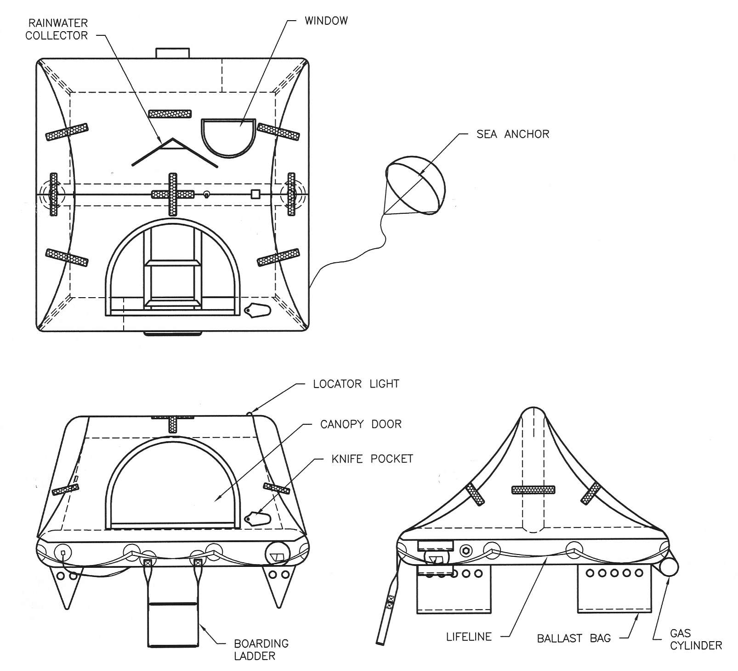

FIGURE 1
REVERE AERO ELITE LIFERAFT
SHOWN INFLATED

4.4 BALLAST BAG SYSTEM

Four (4) ballast bags (water pockets) are attached to the underside of the raft's floor. These deploy underwater as the raft inflates. They fill with water and help prevent the raft from capsizing, especially when the raft is empty or lightly loaded.

  - PRESSURE RELIEF VALVE

The raft is equipped with a pressure relief valve that releases excess inflation gases and prevents the raft from over-inflation. After inflating the raft, you may here a hissing sound of gas escaping through the pressure relief valve. This is normal. The sound should stop after a few minutes.

4.6 Locator Light

A locator light is mounted to the exterior top roof of the raft’s canopy to aid in locating the raft for boarding. The light will illuminate automatically when the raft is inflated and last at least eight hours.

4.7 INFLATABLE INSULATED FLOOR

When the raft is deployed in cold water, body heat is lost through the floor of the raft and can cause hypothermia. To slow this process, the raft is equipped with an inflatable floor that insulates the occupants from the cold water. The floor is inflated manually after boarding by use of the handpump in the survival equipment pack (See Section 8.1).

  - CANOPY DOOR AND WINDOW

The canopy door is closed by means of two zippers. One zipper is on the left hand side of the door and the other is on the right hand side. Zip both zippers towards the top of the door to close. The zippers can be partially lowered to provide ventilation.

The window at the rear of the canopy can also be opened by un-zipping its zipper. Opening both the door and window can allow for cooling cross ventilation if needed. Keep both the door and window closed in cold weather to prevent heat loss or in rainy weather to keep water out.

4.9 RAINWATER COLLECTOR

The exterior rear side of the canopy is designed to catch falling rain water. The plastic tube on the inside of the canopy acts as a spout. Flip open the cap on the end of the plastic tube and the rainwater will pour out. Collect and store the rainwater in spare plastic bags or containers. Recap the tube when finished. The first several cups of rainwater will be salty due ocean spray residue on the exterior canopy and need to be discarded.

4.10 SEA ANCHOR

A fabric sea anchor is attached to the outside of the raft and automatically deploys upon raft inflation. Ensure the anchor is deployed once the raft is boarded. The anchor will aid in stability and prevent the raft from drifting out of the search area.
5.0 PERIODIC SERVICE AND MAINTENANCE

CAUTION: NEVER ATTEMPT TO OPEN THE RAFT PACKAGE AND SERVICE THE RAFT YOURSELF. ONLY A PROFESSIONAL SERVICE FACILITY AUTHORIZED BY REVERE TO SERVICE REVERE ELITE SERIES RAFTS SHOULD SERVICE YOUR RAFT.

REVERE authorized service facilities are experienced in servicing marine type liferafts. The facility will have the current service manual and maintenance documents for this raft as published by REVERE. You can return your raft to REVERE’s own facility listed below for service or contact REVERE for an authorized service facility near you.

REVERE SURVIVAL INC.
Liferaft Service Facility
5323 Highway Ave.
Jacksonville, Florida 32254 USA
Tel. No. (904) 503-9733
Fax. No. (904) 503-9719
www.reveresurvival.com

Your REVERE AERO ELITE SERIES inflatable raft should have its initial periodic servicing performed three (3) years after being purchased. Subsequent periodic servicings should be performed three (3) years after the last servicing.

Periodic 3-year servicing shall include the opening, unpacking, inspecting, testing, repairing, and repacking of the life raft. A leakage test of the inflatable compartments will be performed at each periodic servicing. The raft's inflation cylinder should be removed and weighed at each periodic servicing to determine if it is still correctly filled.

The compressed gas inflation cylinder is also subject to periodic hydrostatic retesting. When the raft is in for its periodic 3-year servicing, the facility shall check the date of the last hydrostatic testing marked on the cylinder. If the hydrostatic retest date is past due, the cylinder must be hydrostatically tested in accordance with U.S. Department of Transportation regulations before being placed back on board the aircraft. The inflation system will also be functionally tested while unattached to the raft and the valve overhauled.

6.0 OPERATING PROCEDURES

6.1 INFLATION

1. Put on your FAA approved life preserver USCG approved inflatable PFD.

2. Gather any gear needed for raft such as ditch bags, emergency radio beacons (PLBs, ELTs), cell phones, signal flares, etc.

3. Move the packed raft from its stowage location to an open door on the aircraft.

4. Remove the flap on the small end of valise. Locate the painterline attached to the backside of the flap.

- Pull the painterline out of valise about six (6) feet (2 meters).

- Secure the free end of painterline to the aircraft to prevent the raft from drifting away. Secure to a strong point such as a seat leg or door handle. (See Figure 2).

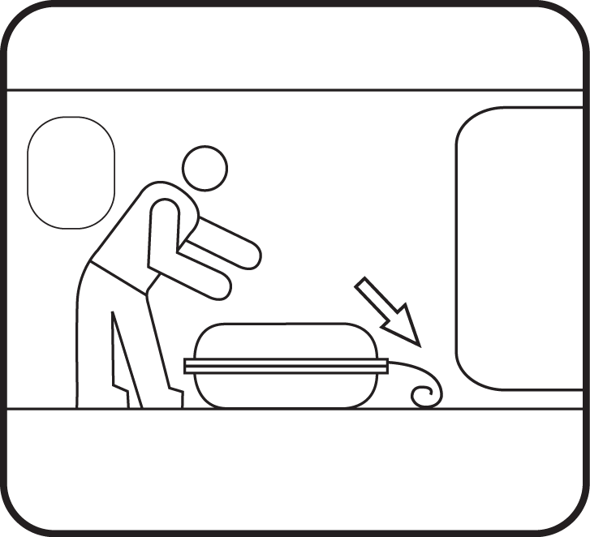

FIGURE 2

NOTE: The painterline is designed to break before the inflated life raft is dragged underwater by the sinking aircraft.

- Throw the packed raft overboard into the water (See Figure 3). Try to keep the top of the valise facing up. The liferaft will float while still packed in its valise.

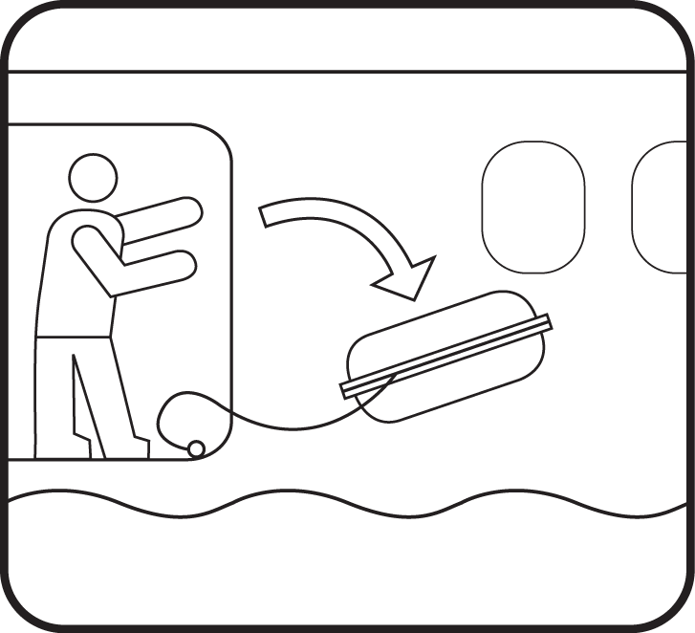

FIGURE 3

- Begin pulling out the remaining painterline packed in the raft package. Extend it until taut and tight. This will require pulling out about 50 feet (15 meters) of line (See Figure 4).

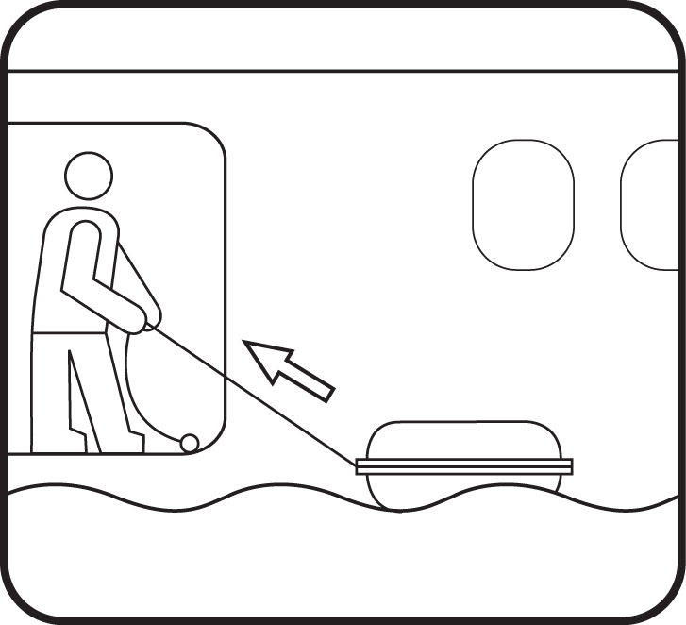

FIGURE 4

9. After pulling out all of the painterline, give a sharp, fast pull. If the raft does not inflate, pull again harder. Continue to pull harder and harder until inflation occurs.

NOTE: The inflation mechanism is not set on a "hair-trigger". A hard, forceful pull of about 25 pounds (12 kg) is needed to begin inflation.

10. Upon inflation, the life raft will burst out of its valise a sea anchor automatically deploys to reduce drift, and a locator light turns on to help you find the raft in the dark. The raft will be ready to board in seconds.

WARNING: THE RAFT INFLATES RAPIDLY AND WITH GREAT FORCE. TO AVOID INJURY, KEEP FACE AND BODY AWAY FROM LIFERAFT VALISE WHEN PULLING THE PAINTERLINE.

CAUTION: THE AERO ELITE SERIES LIFERAFT IS EQUIPPED WITH A CARBON DIOXIDE INFLATION SYSTEM. DO NOT PERFORM A FUNCTIONAL TEST OF RAFT DEPLOYMENT DURING SERVICING, UNLESS NECESSARY. REPEATED DEPLOYMENT, ESPECIALLY WHEN THE RAFT IS NOT IN THE WATER, MAY CAUSE PREMATURE DETERIORATION OF RAFT FABRIC IN THE VICINITY OF THE CO₂ ENTRY PORT. FOR SERVICING PURPOSES, INFLATE RAFT BY INTRODUCING COMPRESSED AIR THROUGH TOPPING-OFF VALVE.
CAUTION: IF DEPLOYING ON DRY LAND FOR SERVICING, TRAINING OR DEMONSTRATION PURPOSES, ENSURE THAT THE AREA IS CLEAN, SMOOTH AND FREE FROM SHARP OBJECTS, SPLINTERS, ABRASIVE AND CORROSIVE MATERIALS. COVER ROUGH WOOD OR CONCRETE SURFACES WITH A TARPAULIN OR CLEAN HEAVY PAPER.
6.2 RIGHTING

The liferaft will almost always inflate right-side-up if it is thrown into the water with the top of the valise or container facing up. Occasionally, the unoccupied raft will inflate upside down or capsize due to wind or wave action. If this occurs, the raft can be easily righted by a person in the water. Always don an FAA approved Life Preserver or an inflated USCG approved PFD before entering the water to right the raft. Once in the water, swim to the raft and flip the raft over about the cylinder using the righting line and handles provided (See Figure 5).
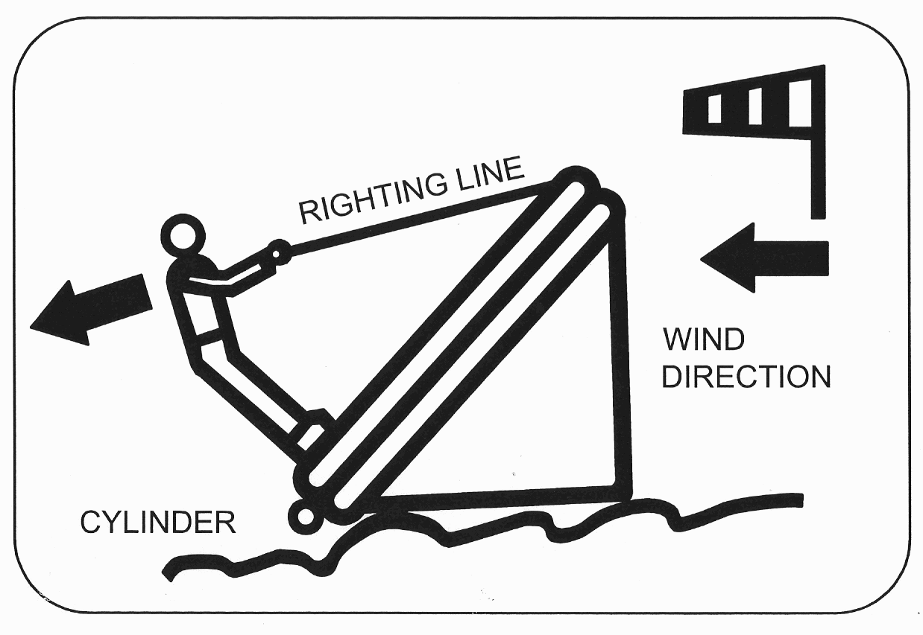

FIGURE 5
RIGHTING PROCEDURES

6.3 BOARDING

1. After the raft has inflated, pull the raft back towards the aircraft by pulling in the painterline.

- With all passengers and crew wearing lifejackets, exit out of the side of the aircraft into the raft. Remember to take any ditch bags, emergency radio beacons, extra signal flares, etc.

- If conditions do not allow you to climb directly from the aircraft into the raft, you should enter the water and swim to the raft’s boarding ladder. Climb up the boarding ladder then pull yourself into the raft. Use the grasp handles provided about the raft.

- Enter the raft one at a time. Hold on to the outer lifeline secured around the raft at the water line until it is your turn to board.

- Injured and unconscious persons should be pulled into the raft with their backs toward the entrance.

- Look for other survivors and haul them in with the rescue heaving line and ring (See Figure 6).

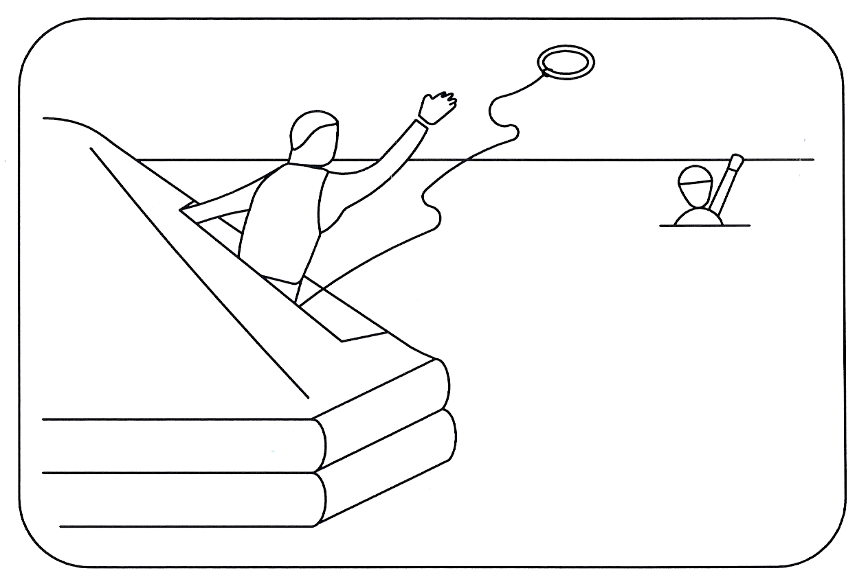

FIGURE 6
USING HEAVING LINE AND RESCUE RING

6.4 CAST-OFF

1. Locate the knife pocket attached to the outside of the canopy by the doorway.

2. Remove the knife from the pocket.

3. Locate the painterline line that is still securing the raft to the aircraft.

4. Cut the painterline with the knife (See Figure 7).

5. Using the paddles in the survival kit pack, paddle away from the aircraft but remain in the general vicinity until it sinks.

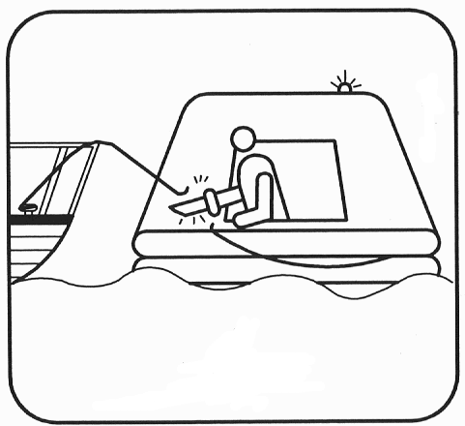

FIGURE 7
CUTTING PAINTERLINE WITH RAFT KNIFE

7.0 IMMEDIATE ACTION CHECKLIST

After boarding raft and casting-off, take these immediate actions:

1. Salvage any floating equipment.

2. Check raft for proper inflation, leaks, and points of possible chafing. Repair punctures immediately with plugs from survival equipment pack (See Section 8.5, "Raft Repair Kit").

3. Raft tube should be firm but not drum tight. If soft, inflate more with handpump (See Section 8.1).

4. Sit low on the raft floor with your back towards the tube.

5. Bail out any water that has entered the raft (See Section 8.3).

6. Check the physical condition of survivors and apply first aid as needed. Take seasickness pills.

7. Keep sharp items out of pockets and away from buoyancy tubes and floor.

8. Activate any emergency radio beacons (ELTs, PLBs, etc.) if available.

- If there is more than one raft, connect rafts with at least 25 feet (8 meters) of line. Connect rafts only at life line around outer periphery of raft. This will make you easier to spot.

- Make a calm estimate of your situation and plan your course of action carefully.

- Ration water and food. Assign duties to raft occupants.

- Keep a log. Record your last known position, names, and conditions of survivors, date and time, and weather conditions.

- Inventory and secure any lose gear including ditch bags, emergency radio transmitters (ELTs, PLBs, etc.), signal flares, etc. if available.

- Keep calm. Do not move around unnecessarily.

8.0 SURVIVAL EQUIPMENT PACK

A survival equipment pack is attached inside the raft to the deck. Several types of kits are available with various raft models. Each has different contents and quantities. Your kit may or may not have all the items described in this manual. You may need to open the kit with the raft knife stowed outside on the canopy.

8.1 TOPPING-OFF WITH HANDPUMP
1. Screw quick-release pump adapter to the handpump. Tighten hand tight. Refer to Figure 8.
2. Locate the topping-off valve in the compartment to be inflated.
3. Open the dust cover at the topping-off valve opening. Attach the pump to the valve by inserting the pump adapter into the valve until the adapter snaps into place. Valve will open automatically.
4. Inflate by applying pumping action to the hand pump until full inflation is achieved.
5. Remove pump from the valve by pulling the adapter away from the topping-off valve until the adapter unsnaps out of place. Valve will close automatically.
6. Close and secure the captive dust cover in place.
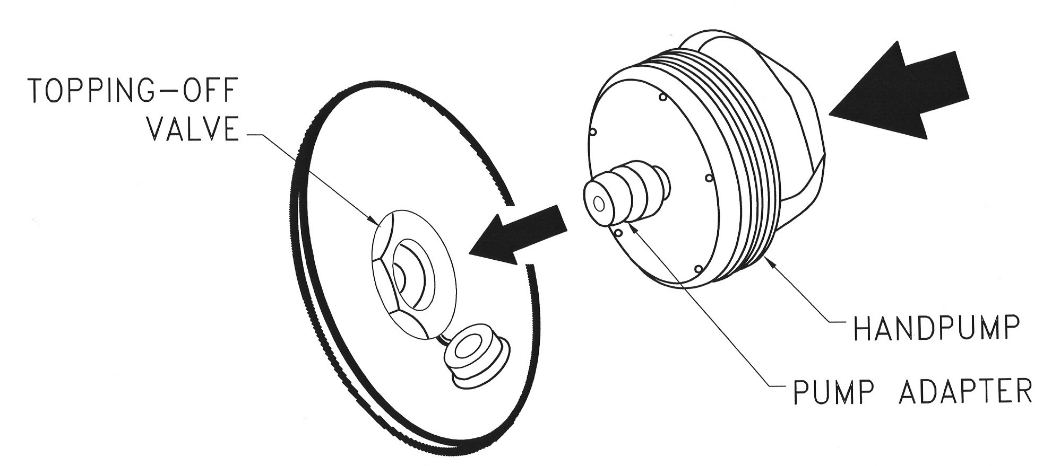

FIGURE 8
HAND PUMP OPERATION

8.2 DEFLATION
1. Remove the captive dust cover at the valve opening.
2. Depress the spring loaded poppet at the center of the topping valve with your finger. Gas will escape from the raft buoyancy tube.
3. Once the desired amount of gas is removed, replace the dust cover.

8.3 BAILING BUCKET AND SPONGES

Use the fabric bailing bucket packed in the survival equipment pack to bail water from the floor of the raft. Keep the inside of the raft dry with the sponges in the equipment pack.

8.4 RAFT REPAIR KIT

The raft repair kit contains rubber plugs of various sizes. Insert plug of appropriate size into the tear or hole.

8.5 PADDLES

The raft survival equipment pack contains two (2) paddles. They can be used to maneuver the life raft for short distances.

8.6 SIGNALING DEVICES

8.6.1 Signal Mirror

Use the signaling mirror even if no aircraft or ships are in sight. They can see the flash of reflected sunlight for many miles, even on hazy days. Follow the directions packed with the mirror.

8.6.2 Whistle

Use in rain, fog, or at night to guide nearby rescuers or to signal other survivors.

8.6.3 Flashlight

Use intermittently at night to conserve batteries.

8.6.4 Pyrotechnic Signal Flares

1. Keep flares dry at all times.

2. Do not waste flares. Use only when possible rescue craft can be seen or heard.

3. Familiarize yourself with the directions marked on the flares. Follow
them completely.

4. Handle flares carefully to avoid burns or damage to raft.

- Hold burning flares away from body and over the side of the raft.

